InComm

TIBCO BW6

**Deployment Guide**

Version 1.0

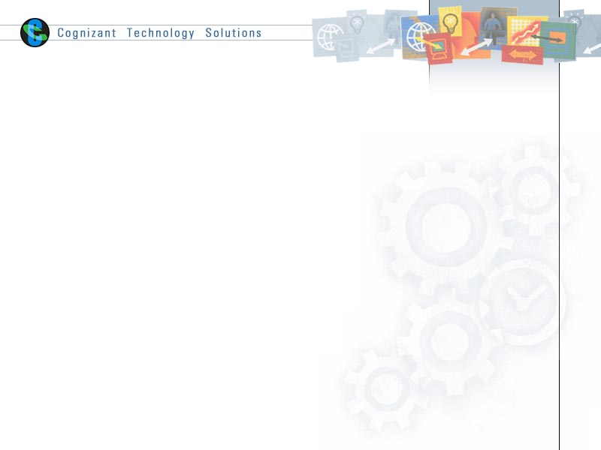

|  |  |  |  |
| --- | --- | --- | --- |
|  | **Prepared By / Last Updated By** | **Reviewed By** | **Approved By** |
| **Name** | Vinay Honnavara |  |  |
| **Role** |  |  |  |
| **Signature** |  |  |  |
| **Date** | 8 Sept 2015 |  |  |

Table of Contents

1.0 Document Overview 3

1.1 Document Purpose 3

1.2 References 3

1.3 Definitions, Acronyms and Abbreviations 3

2.0 TIBCO BW6 Script Deployment 3

2.1 FinancialServices in QA 3

2.1.1 Check Domain & AppSpace 3

2.1.2 Redeploy Financial Services application. 4

2.2 APISecurity in QA 4

2.2.1 Check Domain & AppSpace 4

2.2.2 Redeploy APISecurity application. 5

3.0 Appendix A – Change Log 6

# Document Overview

## Document Purpose

This document is intended to provide guideline for script deployment of BW6 applications

It is required to have TIBCO BW6 and TEA installed and configured successfully as per the product installation document.

## References

Use this section to fill-in reference documents used

|  |  |
| --- | --- |
| ***Document#*** | ***Document Title*** |
|  |  |
|  |  |

## Definitions, Acronyms and Abbreviations

Use this section to fill-in definitions of acronyms & abbreviations used in this document

|  |  |
| --- | --- |
| ***Term, Acronym*** | ***Definition*** |
|  |  |
|  |  |

# TIBCO BW6 Script Deployment

## FinancialServices in QA

### Check Domain & AppSpace

Make sure the Domain “DomainD1_QA” is available and AppSpace2 and its associated AppNodes (AppNode3 & AppNode4) are in “Running” status (as shown in Figure 2.1) .

* Login to “qatibweb01f.privatecloud.local” machine
* Navigate to “opt/tibco/bw/6.2/bin”
* Execute the below commands
  + ./bwadmin
  + “show -d DomainD1_QA appnodes”

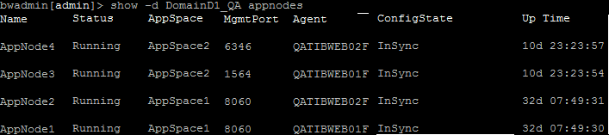

Figure 2.1

### Redeploy Financial Services application.

**Pre-requisites**

* **Files to be available for redeployment**:

/home/tibco/deploy/FS/com.incomm.bw.fsapi.application_*x.x.x*.ear

/home/tibco/deploy/FS/ com.incomm.bw.fsapi.application.substvar

* **Archive Version (*x.x.x*) :** Should be provided by TIBCO team to Deployment team
* **Execute Commands:** Navigate to“opt/tibco/bw/6.2/bin” and

1. ./bwadmin
2. stop -d DomainD1_Dev -a AppSpace2 application com.incomm.bw.fsapi.application 1.0
3. undeploy -d DomainD1_Dev -a AppSpace2 application com.incomm.bw.fsapi.application 1.0
4. upload -d DomainD1_Dev -replace /home/tibco/deploy/FS/com.incomm.bw.fsapi.application_*x.x.x*.ear
5. deploy -d DomainD1_Dev -a AppSpace2 com.incomm.bw.fsapi.application_*x.x.x*.ear
6. config -d DomainD1_Dev -a AppSpace2 -pf /home/tibco/deploy/FS/ com.incomm.bw.fsapi.application.substvar application com.incomm.bw.fsapi.application 1.0
7. start -d DomainD1_Dev -a AppSpace2 application com.incomm.bw.fsapi.application 1.0

Make sure the log file (/opt/tibco/bw/6.2/domains/DomainD1_QA/appnodes/AppSpace2/AppNode3/log/ bwappnode.log) has an entry with deployed date-timestamp. *“Started BW Application [com.incomm.bw.fsapi.application:1.0]”*

## APISecurity in QA

### Check Domain & AppSpace

Make sure the Domain “DomainD1_QA” is available and AppSpace2 and its associated AppNodes (AppNode3 & AppNode4) are in “Running” status (as shown in Figure 2.1) .

* Login to “qatibweb01f.privatecloud.local” machine
* Navigate to “opt/tibco/bw/6.2/bin”
* Execute the below commands
  + ./bwadmin
  + “show -d DomainD1_QA appnodes”



Figure 2.2

### Redeploy APISecurity application.

**Pre-requisites**

* **Files to be available for redeployment**:

/home/tibco/deploy/FS/ com.incomm.bw.apisecurity.application _*x.x.x*.ear

/home/tibco/deploy/FS/ com.incomm.bw.apisecurity.application.substvar

* **Archive Version (*x.x.x*) :** Should be provided by TIBCO team to Deployment team
* **Execute Commands:** Navigate to“opt/tibco/bw/6.2/bin” and

1. ./bwadmin
2. stop -d DomainD1_Dev -a AppSpace2 application com.incomm.bw.apisecurity.application 1.0
3. undeploy -d DomainD1_Dev -a AppSpace2 application com.incomm.bw.apisecurity.application 1.0
4. upload -d DomainD1_Dev -replace /home/tibco/deploy/FS/ com.incomm.bw.apisecurity.application _*x.x.x*.ear
5. deploy -d DomainD1_Dev -a AppSpace2 com.incomm.bw.apisecurity.application _*x.x.x*.ear
6. config -d DomainD1_Dev -a AppSpace2 -pf /home/tibco/deploy/FS/ com.incomm.bw.apisecurity.application.substvar application com.incomm.bw.apisecurity.application 1.0
7. start -d DomainD1_Dev -a AppSpace2 application com.incomm.bw.apisecurity.application 1.0

Make sure the log file (/opt/tibco/bw/6.2/domains/DomainD1_QA/appnodes/AppSpace2/AppNode3/log/ bwappnode.log) has an entry with deployed date-timestamp. *“Started BW Application [*com.incomm.bw.apisecurity.application*:1.0]”*

# Appendix A – Change Log

|  |  |  |  |  |
| --- | --- | --- | --- | --- |
| ***Version Number*** | ***Changes Made*** | | | |
| Vx.y | Initial baseline created on 08-Sept-2015 | | | |
| Vx.y |  | | | |
| **Section No.** | **Changed By** | **Effective Date** | **Changes Effected** |
|  |  |  |  |
| Vx.y |  | | | |
| **Section No.** | **Changed By** | **Effective Date** | **Changes Effected** |
|  |  |  |  |
| Vx.y |  | | | |
| **Section No.** | **Changed By** | **Effective Date** | **Changes Effected** |
|  |  |  |  |